Wheel Plane

Name: ______________________________________ Period: __________

Date: ____________ Date of Absence: _______________

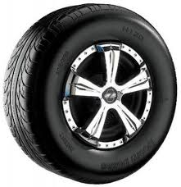
In space we have a set of planes. The first plane is the “Wheel” plane, sometimes this is also called the sagittal plane. This means that movement moves forward and backwards like a wheel. The wheel cannot roll side to side or up and down, it only rolls forward and backward. To understand our bodies and space better we learn about the planes to separate specific movements and clarify those movements in our bodies. Some examples of movements that fit into the “wheel” plane are:

Somersault
Backwards roll
Reaching your arms in front of you
Forward battement
Front Handspring

- Please list 5 movements that are in the wheel plane and describe why they are in that plane ( you may not use the examples above ).

- ____________________________________________________________________________________________________________________________________________________________________

- ____________________________________________________________________________________________________________________________________________________________________

- ____________________________________________________________________________________________________________________________________________________________________

- ____________________________________________________________________________________________________________________________________________________________________

- ____________________________________________________________________________________________________________________________________________________________________

