Name: _______________________________ Period: ________ Date of Absence: _________
Date turned in: __________
LEVEL 2 ABSENT MAKE UP - Much/Little
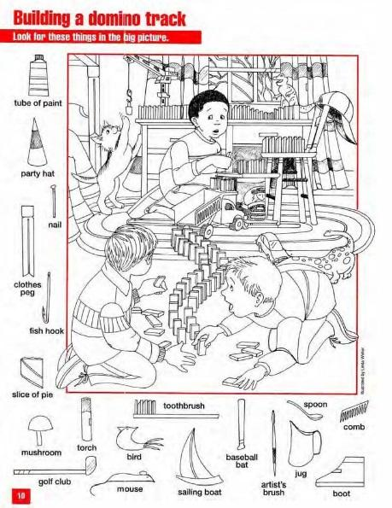
Step 1: Draw a picture with one side filled with “much” or a lot going on at once. Make sure your much side is not only lots of scribbles covering the page but actual things (abstract or literal) inside of it filling the whole thing.
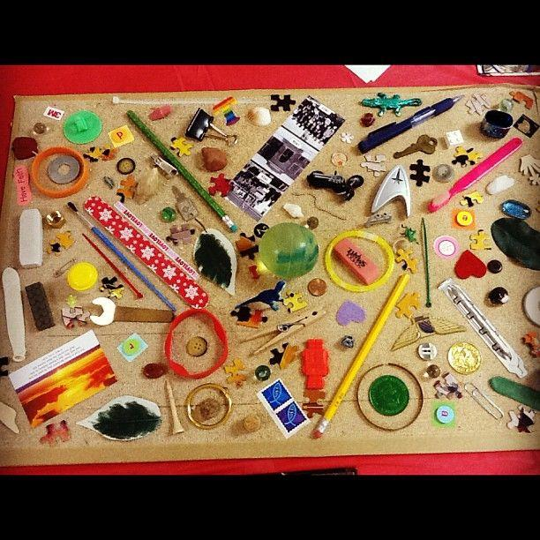

Something like “I spy” or any other picture that has lots of detail would be a great way to go.
←---------------→

Step 2: On the other side of the paper draw a picture that has “little” or not very much on your picture. Maybe focus in on a very small detail or make a design that is very simple on the page. Here are some examples:
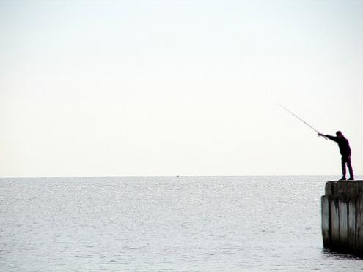
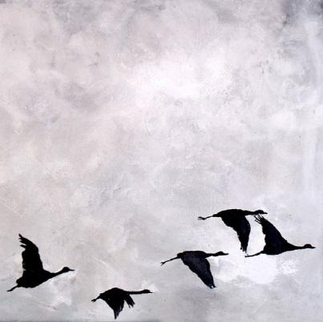

Step 3: Create a phrase of 36 counts of 8 that is representing each picture you drew (so 2 phrases of 36 counts). Think about time, space, and energy. How will you show movement that represents your picture? Be very clear and exaggerated about which phrase is “little” or minimal and which phrase is “much.” ATTACH YOUR DRAWING TO THE BACK OF THIS PAPER AND LEAVE THEM IN YOUR JOURNAL FOR NEXT TIME.
Thought Box: (write all the things you can think of that relate to your inspiration)

