Name: ______________________________________________ Period:_______________
Date:________________________ Date of Absence:_____________

Positive and Negative Space

What is positive and negative space? Positive space in dance is where the dancer's body is when dancing. It is the space where people mostly look when watching dancers. The negative space is the empty air around the dancer.
For example: Look at the donut. The part that you eat is considered positive space. The hole in the middle and everything around it, is the negative space. If you took a bite of the doughnut, would you be making positive or negative space?

Answer:_____________________________________

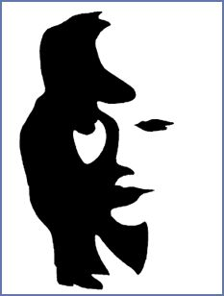
Take a look at the two pictures below.
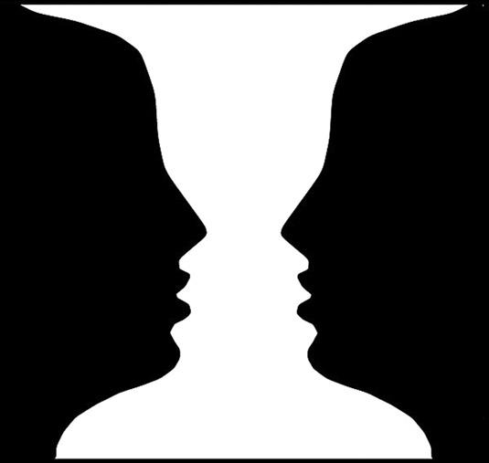

Notice how when you look at the positive space (black) versus the negative space (white) that you see different images. It makes the picture exciting and interesting to look at.

Using an object- chair, ball, human, blanket etc.. Create a 3-6 eight count dance in which you utilize the positive and negative space of the object. Show your teacher your choreography to pass it off. You may choose to do it in silence or with music.

Teacher signature___________________________________

