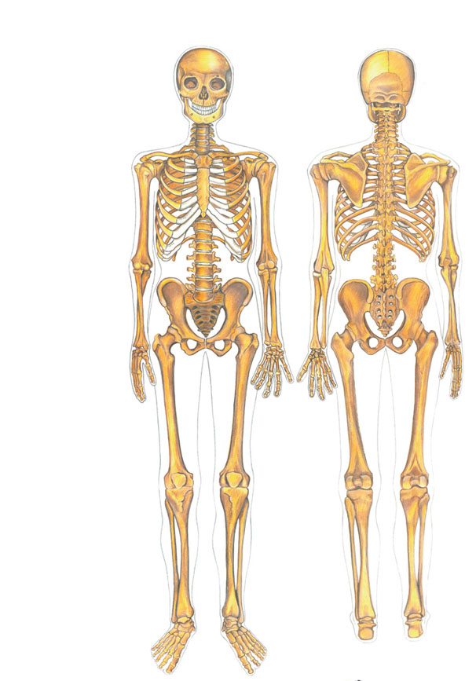
Name: _________________________________________ Period: _______

Please write on the line the name of the bone. Use the key below._________
Cranium Scapula Phalanges
Vertebrae Pelvis Sitz Bones
Sternum Femur Rib Cage
Humerous Patella

