TABLE PLANE:

Name: _____________________________________ Period: _______________

Date: ________________________ Date of Absence: ____________________

Imagine you are between two parallel walls that are only about 2 feet apart from one another. When you are in the table plane (or horizontal plane) you can only travel between these two walls (side to side or left and right). Think of some movements that you could do inside of these two parallel walls - examples are cartwheels, chasse to the side, etc. For this assignment you need to improvise for 2 full songs as if you are inside these two walls (see picture above). When you are done you need to write down 5 “horizontal” movements you did and write a paragraph about how you felt in the improvisation.
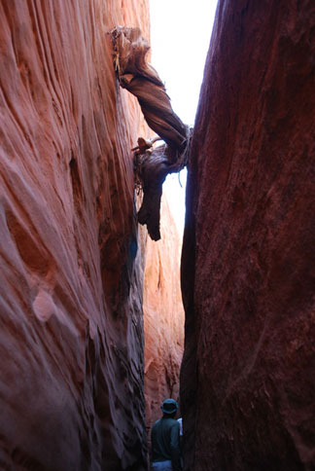
5 Horizontal/Table Movements:

1.

2.

3.

4.

5.

In doing this improvisation I learned:
_____________________________________________
_____________________________________________
_____________________________________________
_____________________________________________
_____________________________________________
____________________________________________________________________________
____________________________________________________________________________
____________________________________________________________________________________________________________________________________________________________________________________________________________________________________

