Manipulate a Motif
Name: __________________________________ Period: __________
Date of Absence: ________________
Today’s Date: ______________

READ
In dance and choreography we have a tool called a motif. This is pronounced MOW-Teef. A motif is defined as a distinctive feature or dominant idea in an artistic or literary composition. WOAH! What does that even mean? It basically means that it is a movement or sequence of movements that is a dominant idea in your choreography. There are motif’s in every art form. In music a common motif that most people will recognize is the theme to “Jaws”. Listen HERE for that motif. It is short and sweet, yet it is dominant and essential to the piece of music. In art we have even more distinct motifs that are a little more obvious to the untrained eye.

These are a few good examples of an artistic motif.
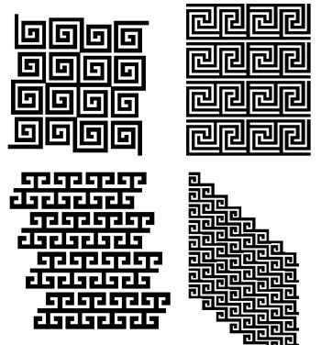
In dance, however our motifs are made up of movement. Yet it is something that is clear and dominant to the choreography. Now that you know what a motif is, we need to talk about how to manipulate it. When you manipulate something it becomes different than the original in some way. In academic dance, we talk about 16 different ways to manipulate a motif. Sometimes this is called theme and variation.

Watch this video and then answer the questions that follow. (Keep in mind that she is a college professor talking to her students so don’t worry so much about what she says about her syllabus. Just watch for the different developments)

This video is about 20 minutes long, but she is English so it is fun to listen to her speak.
MANIPULATING MOTIFS

https://www.youtube.com/watch?v=suzEom1fXdg
RESPOND

Please list the 16 ways to manipulate a motif:
- ______________________________
- ______________________________
- ______________________________
- ______________________________
- ______________________________
- ______________________________
- ______________________________
- ______________________________
- ______________________________
- ______________________________
- ______________________________
- ______________________________
- ______________________________
- ______________________________
- ______________________________
- ______________________________

DANCE
Now choreograph a short motif. NO LONGER THAN 8 COUNTS! Make sure it includes axial and locomotor movement.

Then choose 3 manipulation tools to use and manipulate your motif. List your three choices below.
1. ______________________________
2. ______________________________
3. ______________________________

When you are finished with this assignment, you should have 1 motif, and three manipulations. Please demonstrate ALL of your movement for you teacher and get it passed off.

Teacher Signature: ________________________

