Name: _______________________ Date of Absence: _________ Period:_______ #:_

Bound/Free

Bound: To be confined. Energy cut off.

**Get two pieces of string. Have someone tie your hands together either behind your back or in front of you. Also tie your legs together. Improv for 5 minutes with your body bound in string. After 5 minutes, cut the strings off and dance for another 5 minutes completely free.**

Answer the following questions about your experience in complete sentences:

- What does it feel like to be bound with restrictions of your own body?

- What was the most difficult part about being bound?

- What movement were you able to do while being bound?

- What did it feel like to dance free after your were bound?

- What does being free feel like?

- What movement were you able to do while being free?

- Compare and contrast Bound & Free.
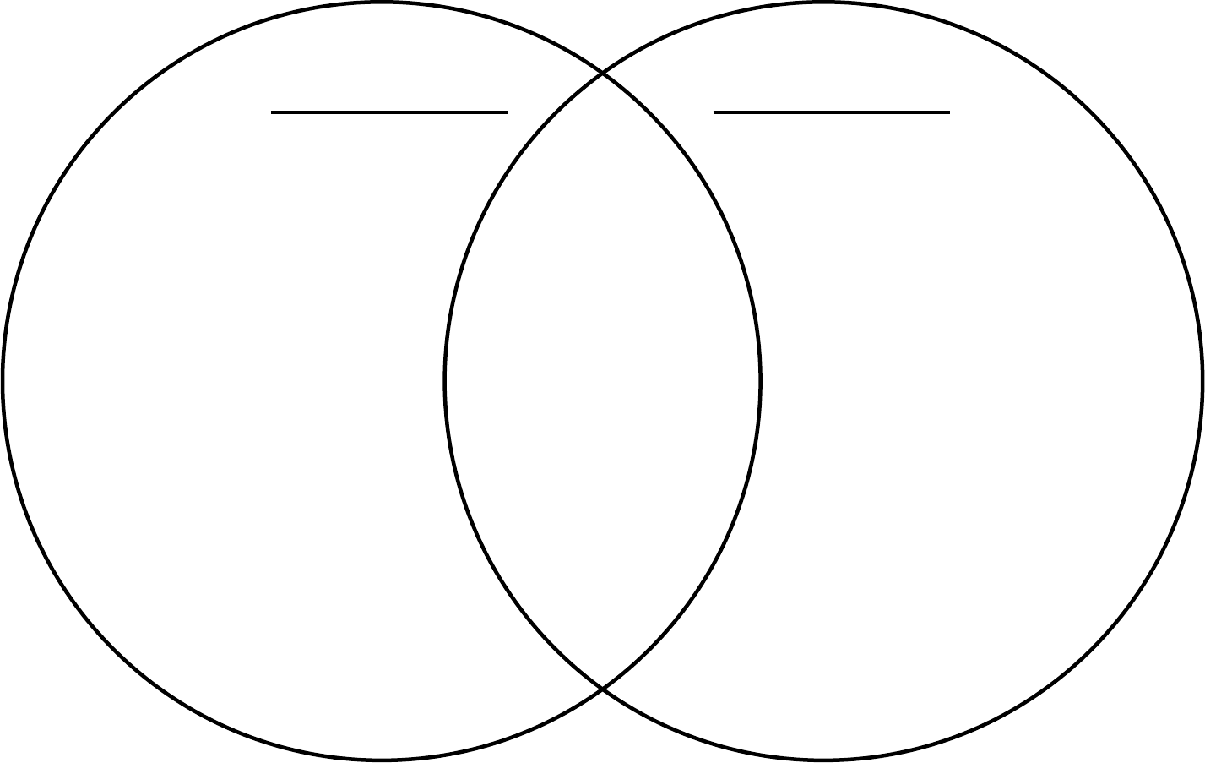
Free
Bound

